1.
a) $\left|OA\right|:\left|OB\right|=2:5$
b) $\left|AB\right|:\left|OB\right|=3:5$
c) $\left|AA'\right|:\left|BB'\right|=\left|OA\right|:\left|OB\right|=2:5$
d) $\left|OA\right|:\left|AB\right|=2:3$
e) $\left|OA^{'}\right|:\left|A^{'}B^{'}\right|=\left|OA\right|:\left|AB\right|=2:3$

2.
a) $x:3=1.6:4$
$$x∙4=3∙1.6$$
$4x=4.8$ / :4
$$x=1.2$$

b) $3:x=5.1:6.8$
$$x∙5.1=3∙6.8$$
$5.1x=20.4$ / :5.1
$$x=4$$

c) $x:3.6=2.5:4.5$
$$x∙4.5=3.6∙2.5$$
$4.5x=9$ / :4.5
$$x=2$$

d) $3.6:(3.6+x)=6.6:7$
$$(3.6+x)∙6.6=3.6∙7$$
$23.76+6.6x=25.2$
$$6.6x=25.2-23.76$$
$$6.6x=1.44$$
$$x=0.22$$

e) $15:35=9:x$
$$15∙x=35∙9$$
$15x=315$ /:15
$$x=21$$

3.
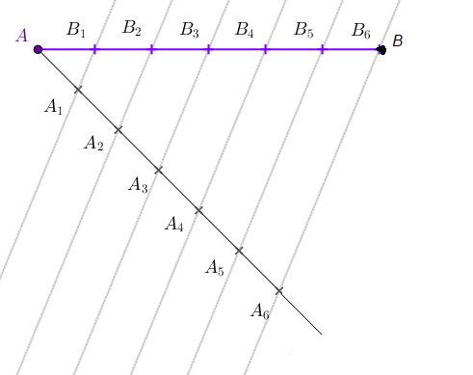

4. a)
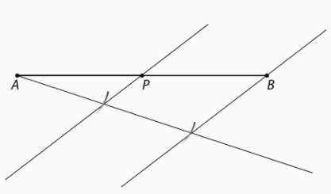

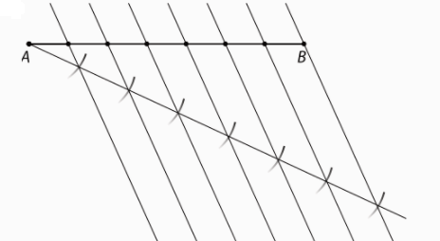
b)

5.
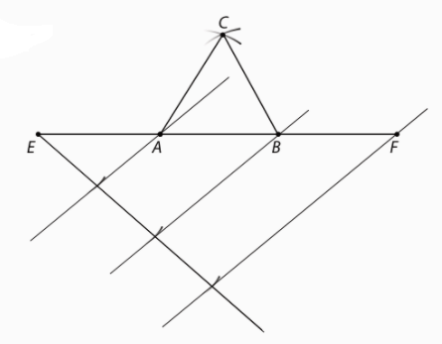
6. a)
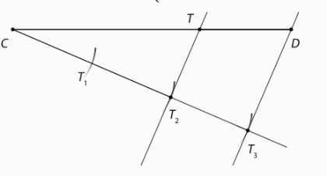

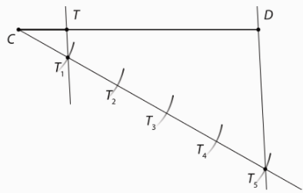
b)

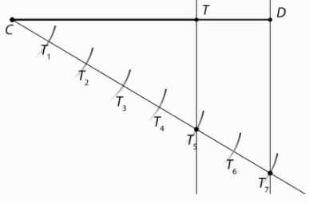
c)

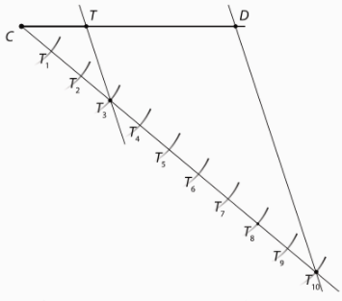
d)

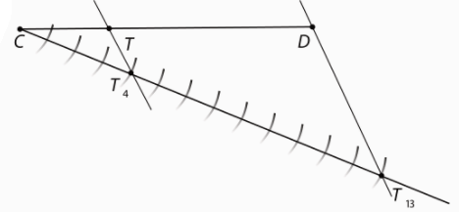
7.

$$\left|CT\right|=\frac{4}{13}∙\left|CD\right|=\frac{4}{13}∙117 mm=36 mm$$
$$\left|TD\right|=\frac{9}{13}∙\left|CD\right|=\frac{9}{13}∙117 mm=81 mm$$

8.
a) A
b) B
c) G
d) D
e) F
f) H
g) C
h) E

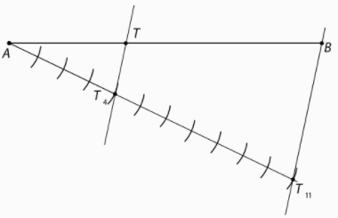
9.

10. a)
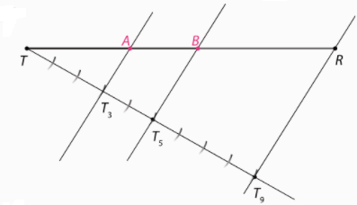
b)
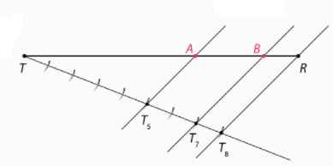
c)
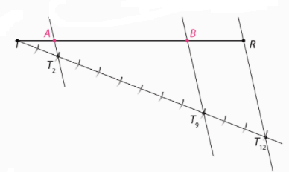

11.a) $1 :\frac{1}{2}:\frac{1}{3}$ /·6
$6:3:2$
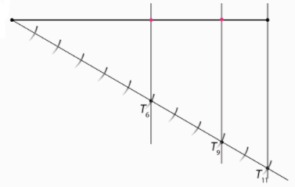
b) $1 :\frac{1}{3}:\frac{1}{9}$ /·9
$9:3:1$
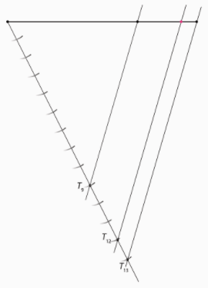

12. a)
$$a:b:c=3:3:5$$
3+3+5 = 11
Dužinu duljine 15.1 treba podijeliti na 11 jednakih dijelova.
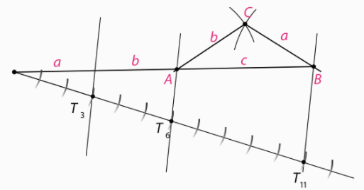
Trokut je jednakokračan i tupokutan.
b) $$a:b:c=3:4:5$$
3+4+5 = 12
Dužinu duljine 15.1 treba podijeliti na 12 jednakih dijelova.
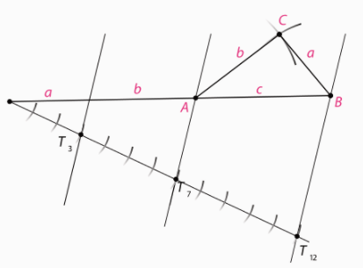
Trokut je raznostraničan i pravokutan,

c) $$a:b:c=2:5:6$$
2+5+6 = 13
Dužinu duljine 15.1 treba podijeliti na 13 jednakih dijelova.

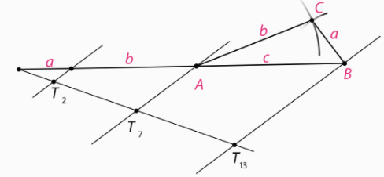
Trokut je raznostraničan i tupokutan.

13.
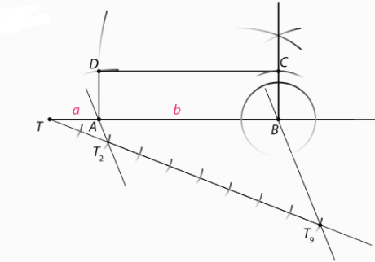

14.
$$a :b :c=3+4+6$$
3+4+6=13 Dužinu duljine 11.7 cm treba razdijeliti na 13 jednakih dijelova.
$$a=\frac{3}{13}o=\frac{3}{13}∙11.7=2.7 cm$$
$$b=\frac{4}{13}o=\frac{4}{13}∙11.7=3.6 cm$$
$$c=\frac{6}{13}o=\frac{6}{13}∙11.7=5.4 cm$$

15.
$$\frac{\left|AD\right|}{\left|DB\right|}=\frac{2}{3}$$
$$\left|AE\right|=3.7 cm$$
$$\frac{\left|AD\right|}{\left|DB\right|}=\frac{|AE|}{|EC|}$$
$$\frac{2}{3}=\frac{3.7}{\left|EC\right|}$$
$2\left|EC\right|=11.1$ /:2
$$\left|EC\right|=5.55 cm$$

16.
$$\frac{\left|PS\right|}{\left|SQ\right|}=\frac{3}{5}$$
$$\left|PR\right|=5.6 cm$$
$$\frac{\left|PS\right|}{\left|SQ\right|}=\frac{|PT|}{|TR|}$$
$$\frac{3}{5}=\frac{x}{5.6-x}$$
$5x=3(5.6-x)$
$$5x=16.8-3x$$
$$5x+3x=16.8$$
$8x=16.8$/:8
$x=2.1$ cm
$|PT|=2.1$ cm

17.
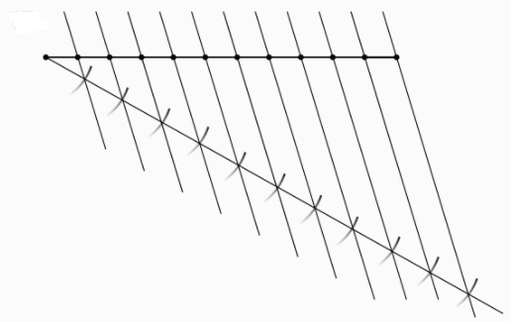
18.
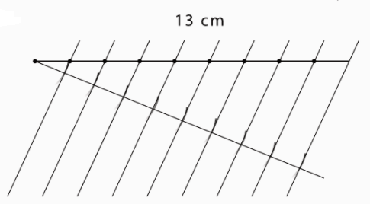
19.
Dužinu duljine 12.3 cm trebamo podijeliti na 3 jednaka dijela.

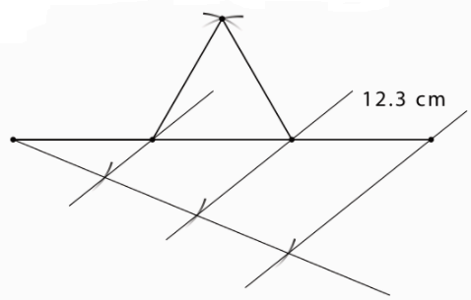
20. Dužinu duljine 13.7 cm trebamo podijeliti na 4 jednaka dijela.
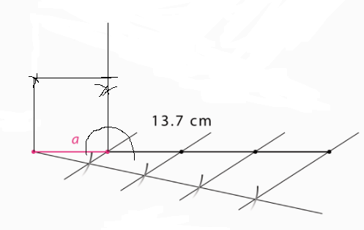

21.
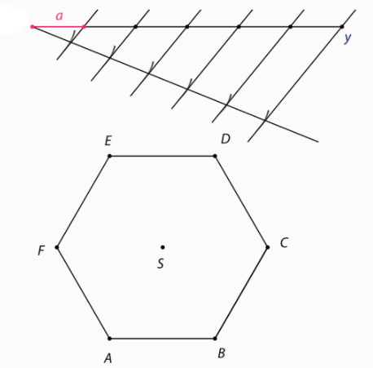

22.
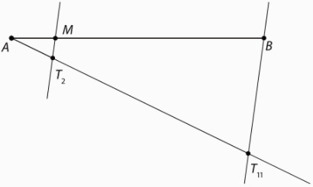

23.
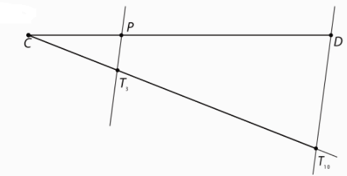
$$\left|CP\right|=\frac{3}{10}∙\left|CD\right|=\frac{3}{10}∙12 Cm=3.6 cm$$
$$\left|PD\right|=\frac{7}{10}∙\left|PD\right|=\frac{7}{10}∙12 cm=8.4 cm$$

24.
a) A
b) B
c) F
d) D
e) E
f) G
g) C

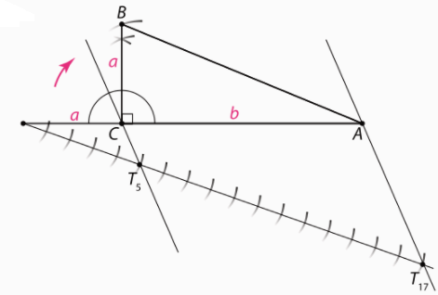
25.

26.
osnovica : krak = 2:3
Dužinu duljine 10.4 treba podijeliti na 2+3+3=8 jednakih dijelova.
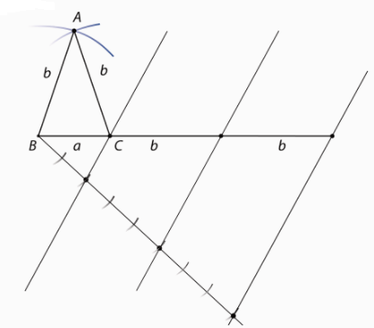
27.
a : b = 1:3
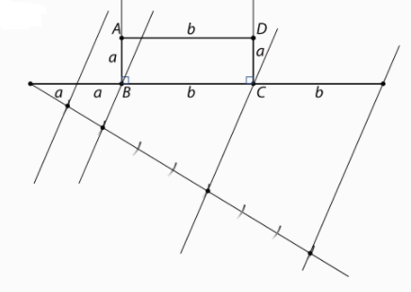

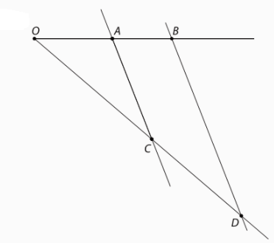
28.
$$a:b=c:d$$
$$4.8 :3.6=9.6 :d$$
$$4.8d=3.6∙9.6$$
$4.8d=34.56$ /:4.8
$d=7.2 cm$

29.
$$a:b=c:d$$
$$6.9 :4.8=c :12$$
$$4.8c=6.9∙12$$
$4.8d=82.5$ /:4.8
$d=17.25 cm$
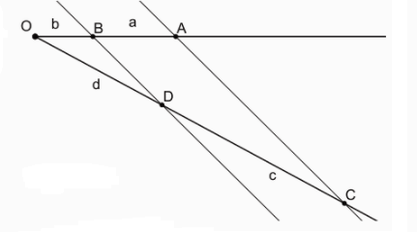

30.
a : e = 4 : 5
$5a=4e$ :/5
$$a=\frac{4}{5}e=6.22 cm$$
a + e=14 cm
$$\frac{4}{5}e+e=14$$
$\frac{9}{5}e=14$/:9/5
$$e=14 :\frac{9}{5}=14∙\frac{5}{9}=7.78 cm$$

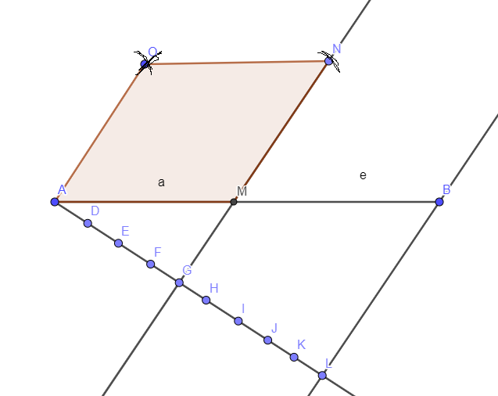

31.
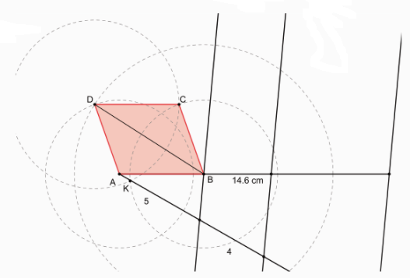

32.
b : a =1.618
a) o = 2m
b=1.618a
2a+2b=o
$$2a+2∙1.618a=o$$
$5.236a=2 m$ /:5,236
$$a=0.382 m=38.2 cm$$
b=1.618a = 0.618 m = 61.8 cm

b) 1 : 10 000
1 cm na karti je 10 000 cm u prirodi, tj. 100 m u prirodi.
2a+2b= 2000 m
$$2a+2∙1.618a=o$$
$5.236a=2000 m$ /:5,236
$$a=382 m$$
b=1.618a = 618 m
$$\frac{1}{100}=\frac{x}{382}$$
$100x=382$ /:100
$x=3.82$ cm

$$\frac{1}{100}=\frac{x}{618}$$
$100x=618$ /:100
$x=6.18$ cm

34.
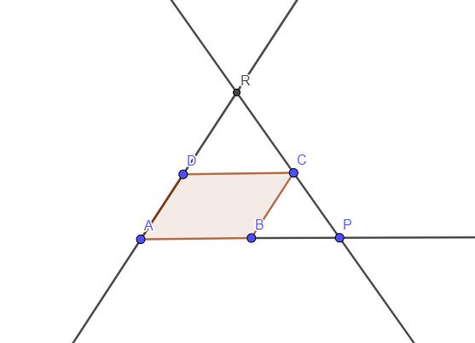

Pravci AP i DC su paralelni, pa možemo primijeniti Talesov poučak o proporcionalnim dužinama.
$$\frac{|DR|}{|AR|}=\frac{|DC|}{|AP|}$$
$$\frac{|DR|}{\left|DR\right|+9}=\frac{15}{21}$$
$$21|DR|=15(\left|DR\right|+9)$$
$$21\left|DR\right|-15\left|DR\right|=135$$
$6\left|DR\right|=135$ /:6
$$\left|DR\right|=22.5 cm$$

35.
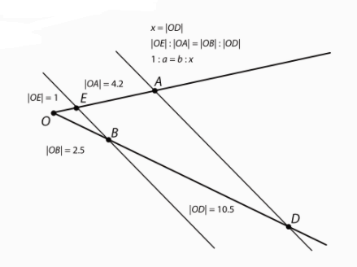
36.
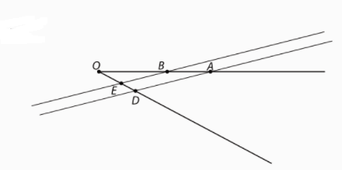

37.
a) h = 5.4 m = 540 cm
540 podijelimo sa 30 da dobijemo broj stuba
540 : 30 = 18
18 stuba, svaka je duga 40 cm, pa slijedi da je
$$d=18∙40=720 cm=7.2 m$$

b) 18 stuba

38.
$$h_{1}=24 m$$
$$h_{2}=36 m$$
$$x :48=h :24$$
24x=48h
$$(48-x) :48=h :36$$
$$48∙36-36x=48h$$
1726 – 36 x =24x
60x = 1726 / : 60
x=28.8 m
h = (24·28.8) : 48
h = 14.4 m

39.
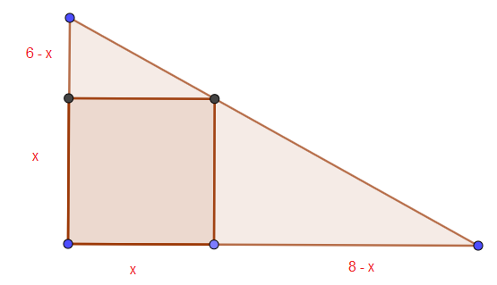
$$\frac{8-x}{x}=\frac{8}{6}$$
$$8x=6(8-x)$$
$$8x=48-6x$$
$$8x+6x=48$$
$$14x=48$$
$x=\frac{48}{14}=\frac{24}{7}$ cm

$P_{k}=x^{2}={\left(\frac{24}{7}\right)}^{2}=\frac{576}{49} cm^{2}$
$$P_{t}=\frac{6∙8}{2}=\frac{48}{2}=24 cm^{2}$$

Razlika $P_{t}-P_{k}=24-\frac{576}{49}=\frac{1176-576}{49}=\frac{600}{49} cm^{2}$

